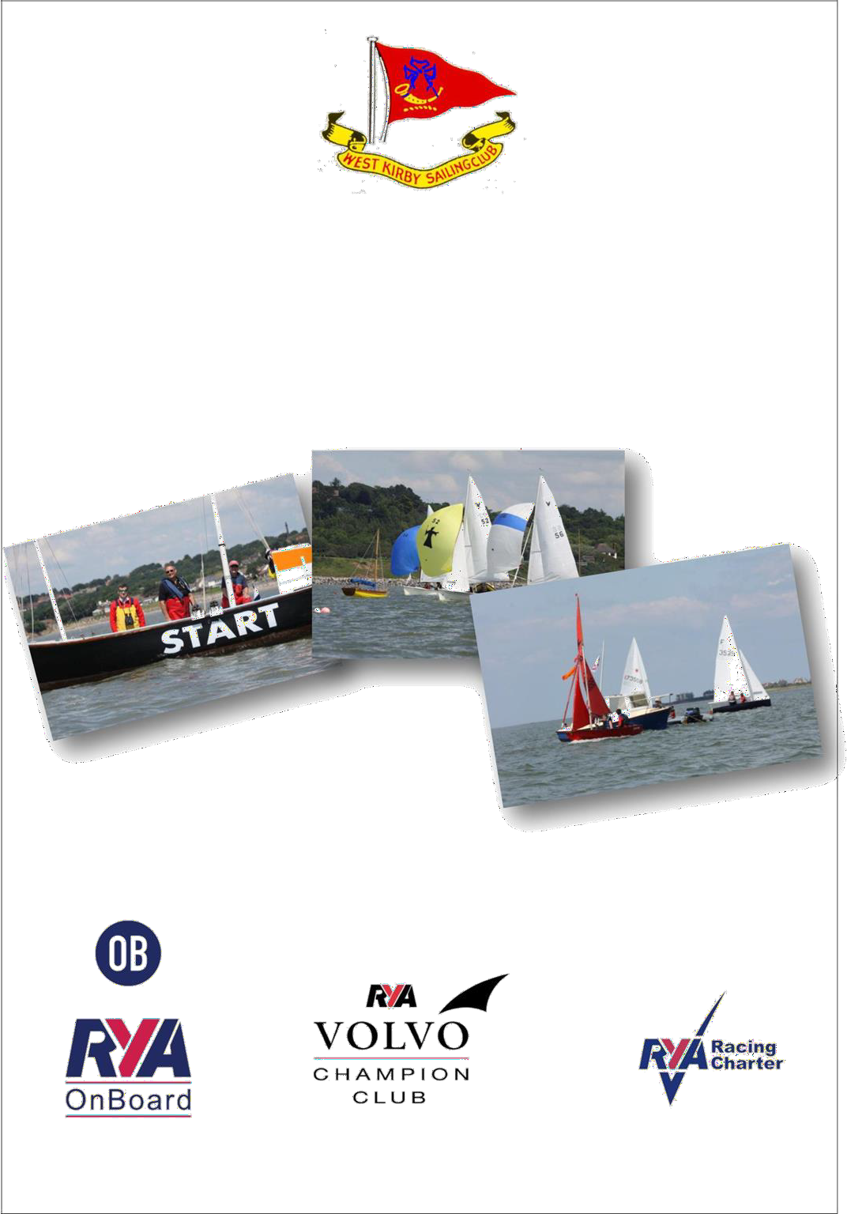
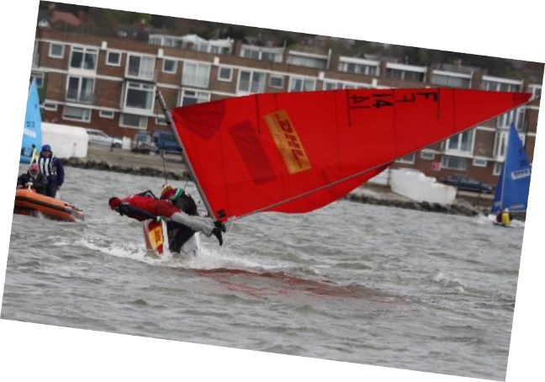

West Kirby Sailing Club
RO’s Guide 2022 - Dinghy Lake

Introduction

Thank you for giving your time to do a club race officer duty.

These notes are intended as a guide to assist in running the racing as efficiently as possible, to the maximum enjoyment of yourselves and competitors alike. It is intended to provide a plain-language guide to the procedures used for standard races at the club. As such, it is not intended to be a complete and definitive document. It is unofficial and shall not be referred to in any protest situation. For official wording you should refer to the general sailing instructions for club racing which is available in your club handbook.

As a reminder, a nominated Race Officer has: -

- The responsibility (under Rule 2) for doing the duty as set out in the Handbook; or providing a replacement and
- The Authority (under Rule 3) of the Sailing Committee in all matters except for deciding Protests and Cancelling Races

We hope you find this guide useful, and any suggestions for items that need to be included in future editions should be sent to us.

Hon. Sailing Secretary
22/03/2022

Contacts

Sailing Secretary |  | Jeanlouis.simons@btinternet.com
Jean-Louis Simons | 07787 516163
Ass. Sailing Secretary (Tidal) | 677 3782 | w-j@whittinghamjones.plus.com
Martin Whittingham-Jones
Ass. Sailing Secretary (Dinghy) | 07787 243875 | martin.hartley2@btinternet.com
Martin Hartley
Official Starter |  | chris.riley.home@gmail.com
Chris Riley | 07733 313 792
Captain | 07741 301191 | captain@wksc.org.uk
Peter Johansen
Rear Commodore Sailing  Chris Riley | 07733 313792 | chris.riley.home@gmail.com
Official Handicapper | 07855 831 060 | anthonymarston@sky.com
Tony Marston
Protest Chairman | 625 6332 | dtaylor@rsk.co.uk
David Taylor
Boatshed | 625 0588 | boatshed@wksc.org.uk
Club House | 625 5579 | office@wksc.org.uk
Race Results | 07855 831060 | results@wksc.org.uk

Before your Duty

- When the handbook is distributed, check if you have been allocated a duty and if so whether you have received an email from Dutyman. If not contact the Sailing Secretary.

- Get yourself some helpers and make sure that all your team are aware of the dates and times that they need to available.

- Preliminary check on weather forecast, several days before your allocated duty and see whether the forecast warrants a rescue cover, such as for example if the wind is predicted to gust over 20 knots. If so, please contact the captain and boatman / boatshed at least three days in advance.

- Check that the marks are in position. If not, notify the boatshed in advance requesting for the marks to be placed back in their correct position.

Note:

The code to enter the Starting room is 1953.

Before the Start

Make sure you arrive in plenty of time, we suggest 60 mins before the advertised start time. This will give you sufficient time to collect the latest weather forecast, equipment. Discuss with the class captains any issues with racing that day and the course you intend to set.

Parking may be an issue at times along the promenade. Give yourself ample time to find a space.

Postponement

If you consider the conditions too severe, or the forecast too poor or other circumstances, which could make it unsafe to sail (e.g. inadequate rescue cover), consult with the Boatman, and speak to Sailing Sec or Rear Commodore Sailing and Class Captain - then make your own decision.
What you need to consider

- Wind Strength and maximum gusts
- Amount of safety boats you have compared to number of boats sailing (it is common on windy days to have at least 1 safety boat to 10 dinghies)
- The ability of the sailors on the water. (Speak to the class captain who will discuss this with the sailors concerned)
- Weather forecast

If you are ashore you should get the Answering Pennant and code flag ‘A’ from the starter’s room and raise these on the main mast. These should remain up until the advertised start time then should be returned to the starter’s room. (Normally hanging on a hook on the left-hand door frame inside the Starters room – please put back there even if wet)
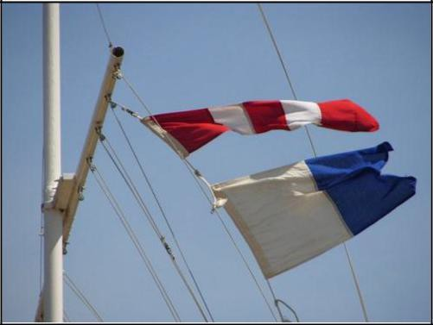

If you are out on the water or on the promenade and the start is going to be delayed (e.g. lack of wind, lack of safety boats), then you should raise the answering pennant and make TWO sound signals.

This should be lowered with ONE sound signal ONE minute before the next starting signal.

Equipment Needed

Dinghies(Lake)
- Club Burgee
- Flag stand
- Class Flag(s)
- Code Flag “P”
- Code Flag “X”
- Code Flag “1st Substitute”
- Code Flag “Answering Pennant”
- Code Flag “S”(Board)
- Code Flag “Q”
- Course Boards
- Stop Watch
- Pens and Pencils
- Rough Pads & Clipboard (as nec.)
- 3 Minute Autohoot
- VHF Radio if there is a safety boat launched
- Club Handbook
Additional equipment you may wish to consider: -

Personal | Larger or special events
Sun cream / screen shackle key  memo recorder batteries pencils, pens burgee  cotton wind indicator neck towel  fingerless gloves woolly hat, baseball cap  recording sheets & plain notepad | clipboards (2) Rule Book  SIs for the event Extra VHF radio Mobile phone binoculars  gas air horn whistles (2) anemometer waterproofs buoyancy aid  snacks (food & drink)

Setting the Course Lake Sailing
The lake course card describes the wind directions that are suitable for certain directions. Speak to the class captains for advice on courses for the day. Be prepared to take more course boards than you think you need in case the wind changes direction.
Be aware that the lake is not a perfect rectangle and the wind on the promenade may not be reflecting the wind direction on the lake. If necessary, ask competitors to sail to windward to give you a better indication of the wind direction.

Setting the Start Line

This is one area that often gets commented on by competitors. Your aim is to make the line as fair as possible to all competitors so that there is not too much bias on one end of the line. The aim is getting the line as close to a right angle of the wind as possible. The first leg of the course should be to windward. Marks South ($) and North (N) can easily be moved by competitors.

Lake Starts
The start line is between the burgee on the promenade and the mark
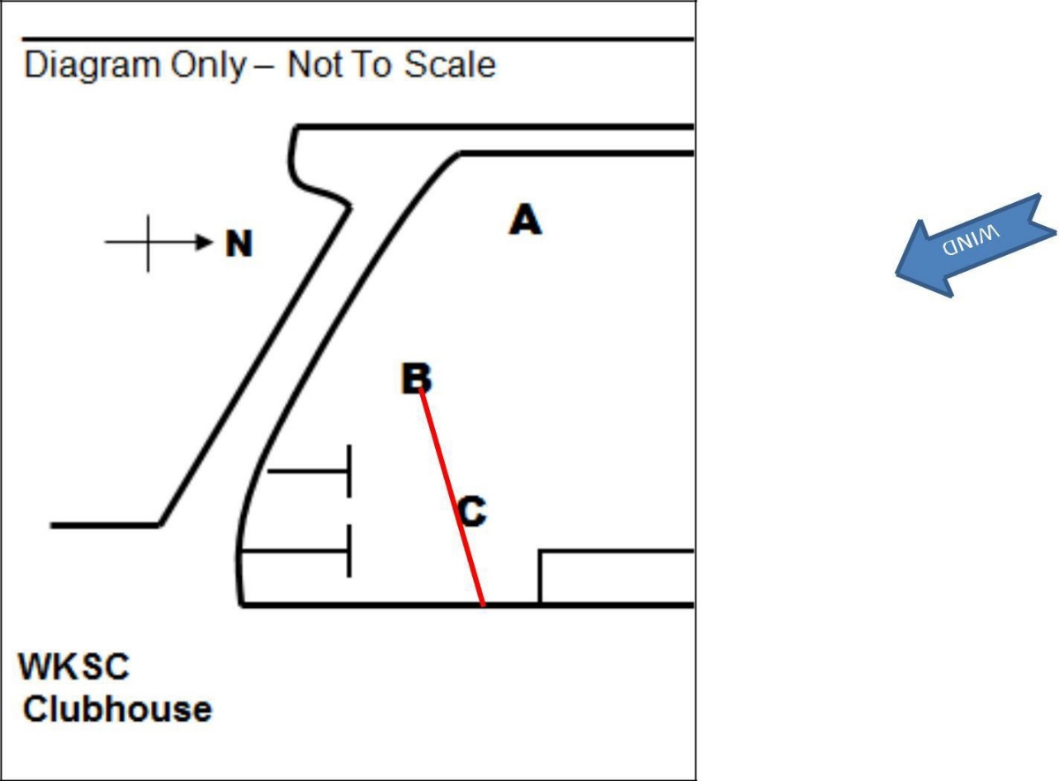
2
S
1
There is nothing to stop you having the burgee position on the old baths if this means the competitors get a good start line. Ideally the wind should strike the line (close to) at right angles

The start line should be checked regularly to make sure there isn’t a wind shift during the starting sequence, or if there is a change in between races.

Average Lap Times (for Club Handicap Racing)

The Race Officer may, at his sole discretion, choose to run Handicap racing using Average Lap Times by displaying Code Flag B from the Race Committee Station throughout the starting sequence of the race concerned.

If using average lap timings don’t alter the course in any way or move the Start Line after the start until the finish of the race.

Starting Sequence

On the lake races will be started at 3 minute intervals (WKSC Sailing Instruction 10.2)

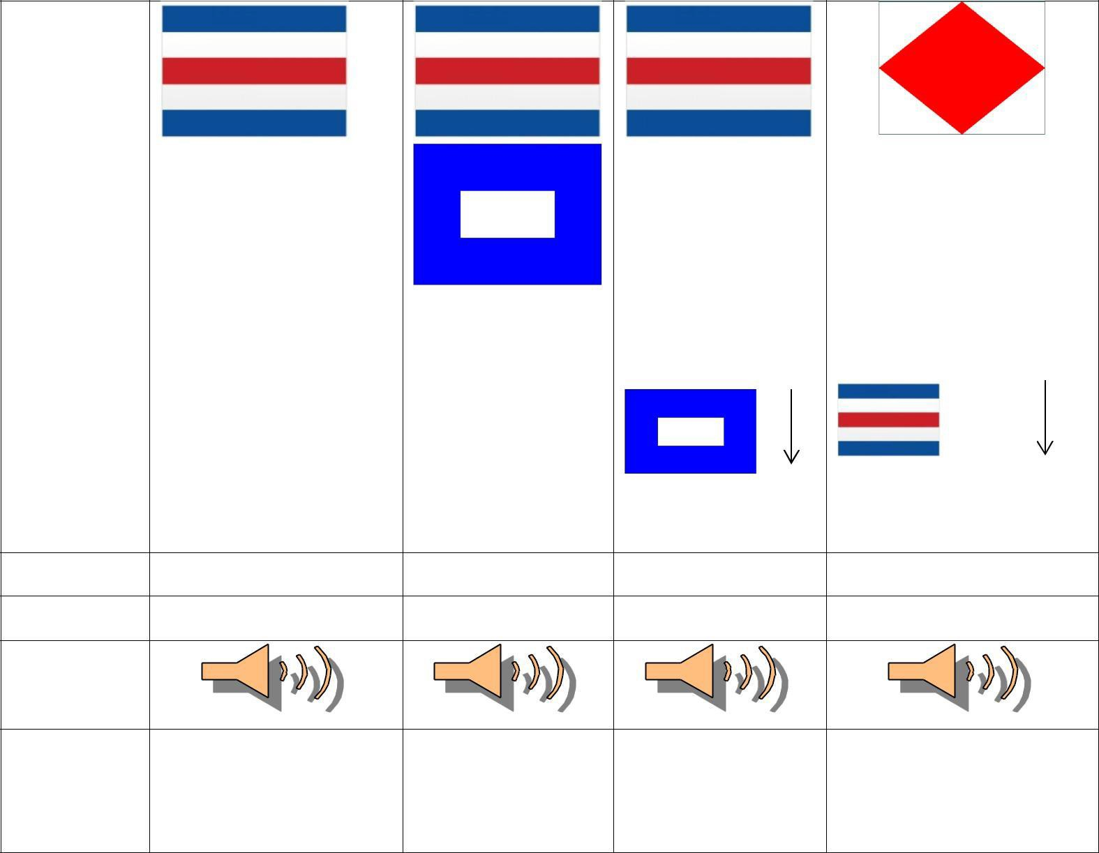
This is an example of the starting sequence for the Solo class with the Firefly class warning signal being raised at the start.

Signal | Warning | Preparatory |  | Start
Time | 3 Minutes | 2 Minutes | 1 Minute | 0 Minutes
Sound
Signal
Description | Code Flag “C” raised | Code Flag “P” | Code flag “P” | Code flag “C” lowered
 | accompanied by one | raised | lowered | and code flag “F” raised
 | sound signal | accompanied by | accompanied on | accompanied by one
 |  | one sound signal | one sound signal | sound signal

Boats that are Over the Line – Individual Recalls

If a boat is over the start line you should sound an additional sound signal and raise code flag “X”

This should be lowered when all the boats have returned, until 1 minute before the next start or not longer than 2 minutes.

Boats should be recorded as OCS (On Course Side) on the results
sheet. You should continue to include them within your written results in case there is a dispute when coming ashore and the offending boat requests redress. However you should make it clear on the final copy that they were over the line.

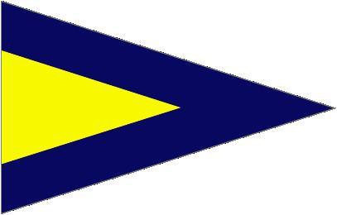
Improper Starts – General Recalls

If there are boats over the line and you can’t identify them all you may decide to restart the entire race.
This should be done by raising the 1st Substitute flag accompanied by TWO long sound signals.

The recalled class may be restarted immediately or after the last class within a sequence. The next warning signal should be made 1 minute after lowering the 1st substitute accompanied by ONE sound signal.
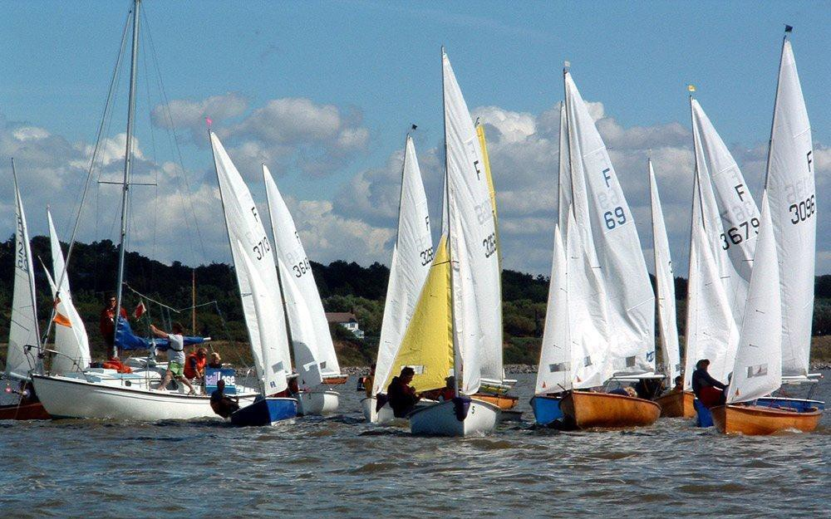

During the Race

You should record the positions of the boats after each lap. You should also record the time of rounding for the 1st boat and last boat, so you can work out how many laps to send them.
For handicap races you need to record the length of time of racing. On the starting signal you should start another stop watch and record the total elapsed time for each boat. It is important that you identify the classes of every boat. If you are unsure ask someone. Some classes use different sail sizes and unless you are familiar with them they can be difficult to identify, e.g. Laser and Laser Radials.

Length of Race
You should aim to make sure that races are of a suitable length. The first boat should have a race of at least a minimum of 45 minutes. Normal race lengths are normally around 60 minutes.

You have to consider the tail enders when deciding on the timings, but generally sailing on the lake, even in the evening, there is sufficient daylight to ensure a decent length race is given to the leading boats.

Early Termination of Racing

If you consider a race to be concluded but not all the competing boats have finished. You should raise code flag “Q” and make ONE sound signal. Boats not finished should be recorded as retired. (RET)

Shortening Course

Course shortening is done by raising Code Flag S, together with the appropriate Class Flag(s) and making 2 sound signals. This is traditionally when the leading boat in the race has just rounded the last mark.

Shortening may also be affected at any rounding mark of the course by positioning a Committee Boat (e.g. RIB) or standing along the promenade, flying a Blue Flag and code flag ‘S’. The Committee Boat should be positioned on the side of the buoy that the boats would normally pass if they were continuing the course and square to the general direction from the previous mark thereby creating a Finishing Line.

*** PLEASE TRY TO MAKE THE FINISH FAIR AND THE DIRECTION TO PASS THROUGH THE LINE OBVIOUS ***

The shortened course flag (S) and the class flag may be raised (along with making the 2 sound signals) at any time prior to the leading boat crossing this line. However, good practice would suggest that adequate time is given to allow boats to cross this line without major course changes.

On the lake races are “Open ended” in other words there are no fixed number of laps. It is up to the race officer to decide when to shorten the course. This should be done when boats have rounded the marks which have been highlighted on the course cards in bold and underlined.

Abandoning a Race
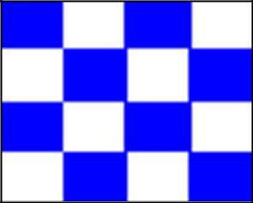
The race officer may abandon a race at any time by making THREE sound signals and flying flag N.

Examples of reasons races are abandoned could be (watch stopped, course problems).

This should be lowered ONE minute before the next starting signal accompanied by ONE sound signal.

Finishing the Race
As the boats cross the line give the first 3 in each class a quick sound signal. Record the sail number and the elapsed time of finishing (handicap races).

When all boats have finished take the shortened course flag down (if being used) and start the next race or start to pack up.

If on the lake, make sure that you take everything with you and is put away in the starters room.

If anything was missing or has been damaged, please contact the Official Starter as a matter of urgency.

Recording the Results

Write up results and take a picture of it. Send the picture to results@wksc.org.uk . Post the written copy in the correct slot in Club foyer. You should also put a copy in the box in the race officer’s cupboard. This is just in case one goes missing.

It is important to make sure that what you write is correct. If a result is recorded wrong, it is up to the competitor and the race officer to inform the sailing secretary of the correct result as soon as possible after the results have been posted.

If there are any protests and you are given the Protest Form, sign it with date and time – Again take a picture of the duly completed protest form and email it to the Protest Chairman and the Sailing Secretary. The hard copy should be placed in the appropriate slot in the foyer.

Finally

Your final duty of the day is to lower the club burgee and ensign off the main mast. (This remains up if the ensign is at half-mast).

Dutyman

You will be emailed 7 days and 3 days before your race officer duty to remind you. If you haven’t, let us know your current email address. You need to do this as soon as possible.

The dutyman system allows you to swap your duties with other people. All the information is available on the dutyman website.

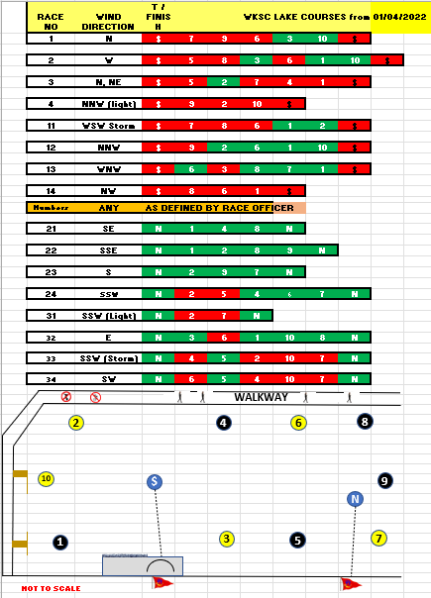

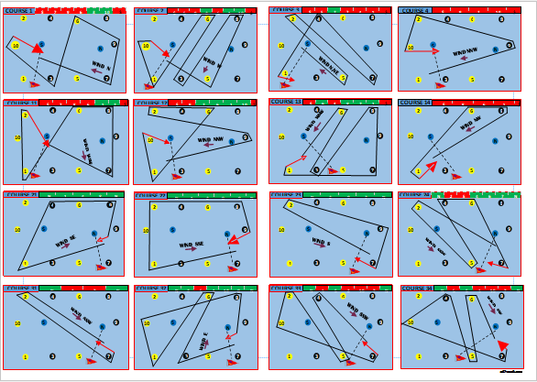

Page 12 © WKSC 2019

Notes

Page 13 © WKSC 2019

