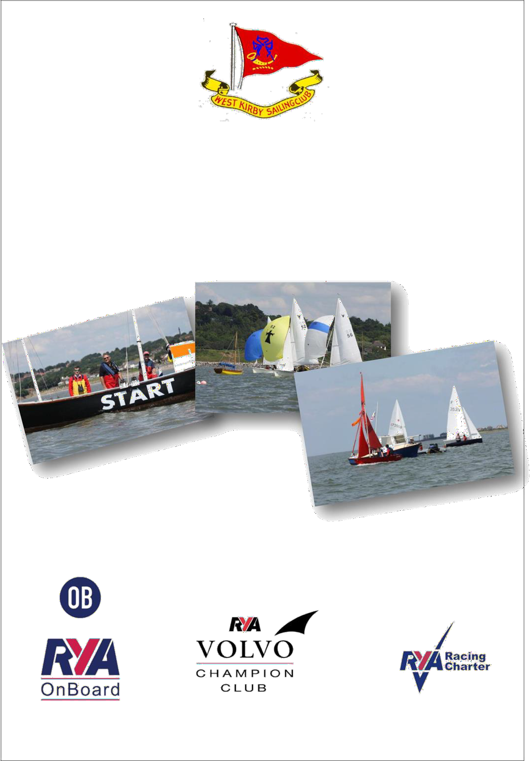

West Kirby Sailing Club
R.O. Guide 2022 – Dinghies Tide

Introduction

Thank you for giving your time to do a club race officer duty.

These notes are intended as a guide to assist in running the racing as efficiently as possible, to the maximum enjoyment of yourselves and competitors alike. It is intended to provide a plain-language guide to the procedures used for standard races at the club. As such, it is not intended to be a complete and definitive document. It is unofficial and shall not be referred to in any protest situation. For official wording you should refer to the general sailing instructions for club racing which is available in your club handbook.

As a reminder, a nominated Race Officer has:-

- The responsibility (under Rule 2) for doing the duty as set out in the Handbook; or providing a replacement and
- The Authority (under Rule 3) of the Sailing Committee in all matters except for deciding Protests and Cancelling Races

We hope you find this guide useful, and any suggestions for items that need to be included in future editions should be sent to us.

Hon. Sailing Secretary

Contacts

Sailing Secretary |  | Jeanlouis.simons@btinternet.com
Jean-Louis Simons | 07787 516163
Ass. Sailing Secretary (Tidal) | 677 3782 | w-j@whittinghamjones.plus.com
Martin Whittingham-Jones
Ass. Sailing Secretary (Dinghy) | 07787 243875 | martin.hartley2@btinternet.com
Martin Hartley
Official Starter |  | chris.riley.home@gmail.com
Chris Riley | 07733 313792
Captain | 07741 301191 | captain@wksc.org.uk
Peter Johansen
Rear Commodore Sailing  Chris Riley | 07733 313792 | chris.riley.home@gmail.com
Official Handicapper | 07855 831 060 | anthonymarston@sky.com
Tony Marston
Protest Chairman | 625 6332 | dtaylor@rsk.co.uk
David Taylor
Boatshed | 625 0588 | boatshed@wksc.org.uk
Club House | 625 5579 | office@wksc.org.uk
Results | 07855 831060 | results@wksc.org.uk

Before your Duty

- Get yourself some helpers and make sure that all your team are aware of the dates and times that they need to available. You should have a minimum of one helper to ensure you are able to do your duty.

- Contact the rescue duty boat/person to make sure they are organised. Contact the club captain or Boatman who will advise who is doing rescue that day and which RIBs have been allocated to them.

- Preliminary check on weather forecast.

- If using Little Arvor speak to Boatman if you are concerned about driving it

Before the Start

Make sure you arrive in plenty of time.

For tidal sailing about 3 ½ hrs before high water is sufficient. This will give you sufficient time to collect the latest weather forecast, equipment and discuss with the class captains any issues with racing that day. You should also check with the Captain / Boatman / rescue volunteers. that all necessary pillar boys, starting line pin mark are on board. The mark layer and rescue volunteers should also be aware of which course you intend to set and where.

Postponement

If you consider the conditions too severe, or the forecast too poor or other circumstances, which could make it unsafe to sail (e.g. inadequate rescue cover), consult with the Boatman, and speak to Sailing Sec or Vice Commodore and Class Captain - then make your own decision.

What you need to consider

- Wind Strength and maximum gusts
- Amount of safety boats you have compared to number of boats sailing (it is common on windy days to have at least 1 safety boat to 10 dinghies)
- The ability of the sailors on the water. (Speak to the class captain who will discuss this with the sailors concerned)
- Weather forecast

If you are ashore, you should get the Answering Pennant and code flag ‘A’ from the starter’s room and raise these on the main mast. These should remain up until the advertised start time then should be returned to the starter’s room. (Normally hanging on a hook on the left-hand door frame inside the Starters room – please put these back even if wet)
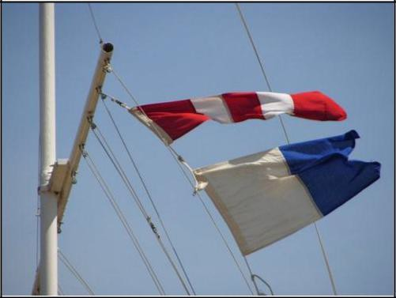

If you are on the water and a start is going to be delayed (e.g. lack of wind or lack of safety boats), then you should raise the answering pennant and make TWO sound signals.

This should be lowered with ONE sound signal ONE minute before the next starting signal.

Equipment Needed

Tidal Starting
- Flag Roll – confirm if on the Dinghy Start Boat.
- Horn - 3 Minute Autohoot (Dinghy) Or Tidal Horn for use on the Ark
- VHF Radio
- Stopwatch
- Pens and Pencils
- Rough Pads & Clip Board
- Club Handbook
- Lifejacket / Buoyancy Aid

The following is on board the Ark:
- Flag Roll
- Course Number Boards
Additional equipment you may wish to consider:-

Personal | Larger or special events
Sun cream / screen seasickness tablets paracetamol  insect repellent shackle key duct tape memo recorder batteries pencils, pens burgee  cotton wind indicator neck towel  fingerless gloves woolly hat, baseball cap  recording sheets & plain notepad | clipboards (2) Rule Book  SIs for the event Extra VHF radio Mobile phone binoculars  gas air horn mouth-blown horn whistles (2) anemometer  hand-bearing compass GPS  complete flag set (including orange, black, red, green & blue)  waterproofs buoyancy aid  snacks (food & drink)

Setting the Course

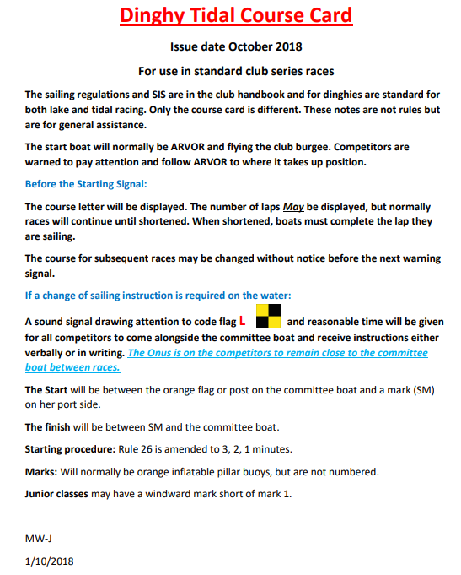

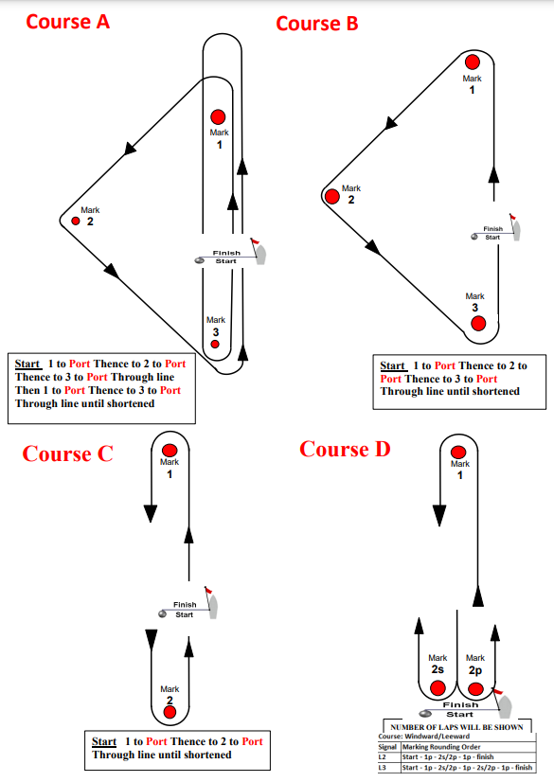

The RO should choose one of the above 4 options and display a board with the appropriate letter on the side of the starting boat, before the starting signal.

Setting the Start Line

This is one area that often gets commented on by competitors. Your aim is to make the line as fair as possible to all competitors so that there is not too much bias on one end of the line. The aim is getting the line as close to a right angle of the wind as possible. The first leg of the course should be to windward.

` Much consideration should be given to the tidal flow which will impact dinghies preparing to start.

The start line should be checked regularly to make sure there isn’t a wind shift during the starting sequence, or if there is a change in between races.

Average Lap Times (for Club Handicap Racing)

The Race Officer may, at his sole discretion, choose to run Handicap racing using Average Lap Times by displaying Code Flag B from the Race Committee Station throughout the starting sequence of the race concerned.

If using average lap timings make sure every lap is the same length (eg NOT course A) and don’t alter the course in any way or move the Start Line after the start until the finish of the race.

Don’t forget that, besides recording the lap times, it is also helpful to record the total number of laps each boat sails in a race.

Starting Sequence

Tidal races will be started with intervals between starting signals being 3 minute (WKSC Sailing Instruction 10.2). This is an example of the starting sequence for the Solo class with the Firefly class warning being raised at the start.
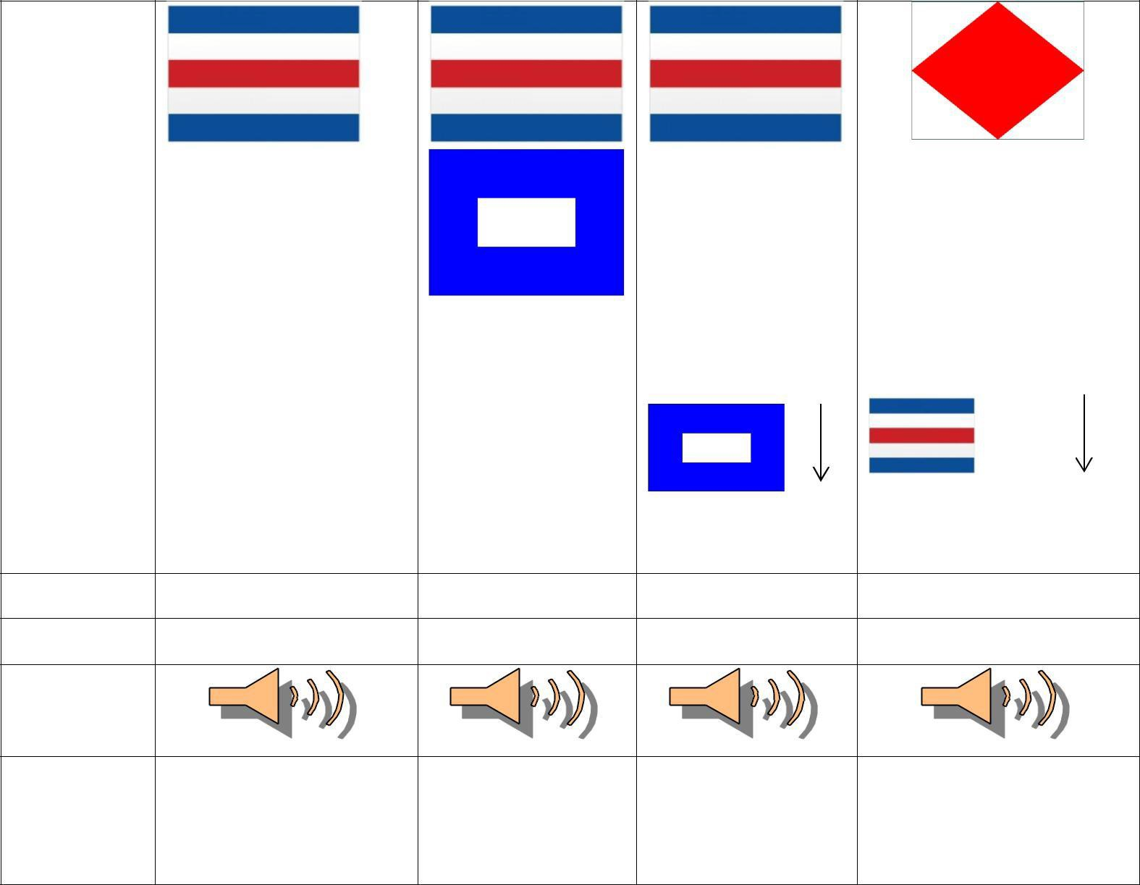

Signal | Warning | Preparatory |  | Start
Time | 3 Minutes | 2 Minutes | 1 Minute | 0 Minutes
Sound
Signal
Description | Code Flag “C” raised | Code Flag “P” | Code flag “P” | Code flag “C” lowered
 | + one sound signal | Raised + | Lowered + | and code flag “F” raised
 |  | One sound signal | one sound signal | + one sound signal

Boats that are Over the Line – Individual Recalls

If a boat is over the start line you should sound an additional sound signal and raise code flag “X”

This should be lowered when all the boats have returned or for not longer than 2 minutes.

Boats should be recorded as OCS (On Course Side) on the results
sheet. You should continue to include them within your written results in case there is a dispute when coming ashore and the offending boat requests redress. However you should make it clear on the final copy that they were over the line.

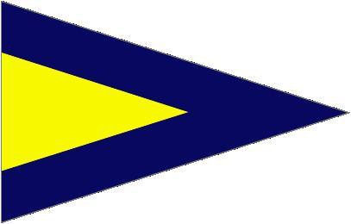
Improper Starts – General Recalls

If there are boats over the line and you can’t identify them all you may decide to restart the entire race.
This should be done by raising the 1st Substitute flag accompanied by TWO long sound signals.

The recalled class may be restarted immediately or after the last class within a sequence. The next warning signal should be made 1 minute after lowering the 1st substitute accompanied by ONE sound signal.
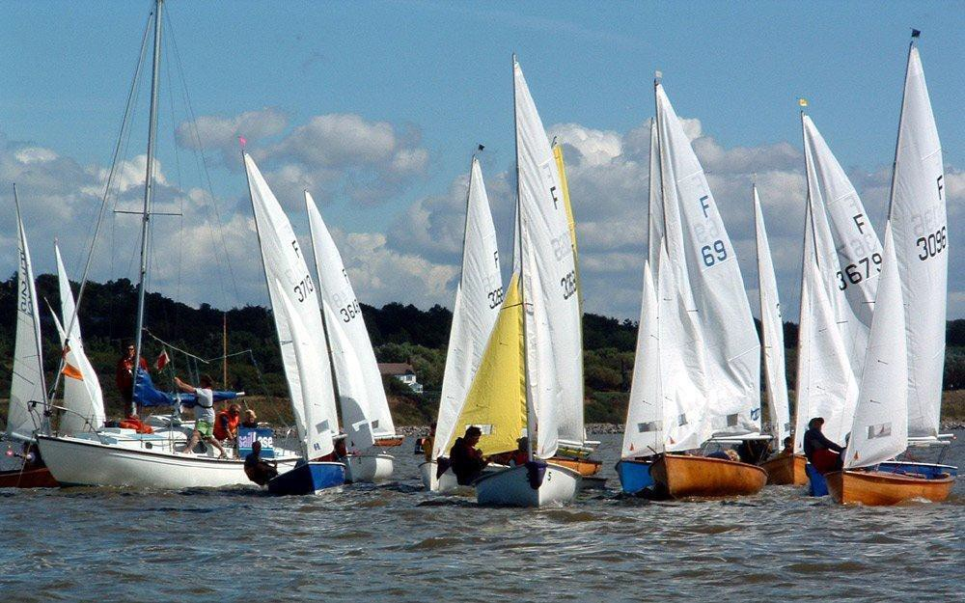

During the Race

You should record the positions of the boats after each lap. You should also record the time of rounding for the 1st boat and last boat, so you can work out how many laps to send them.
For handicap races you need to record the length of time of racing. On the starting signal you should start another stopwatch and record the total elapsed time for each boat. It is important that you identify the classes of every boat. If you are unsure ask someone.
Some classes use different sail sizes and unless you are familiar with them, they can be difficult to identify, e.g. Laser and Laser Radials.

Length of Race

You can comfortably race until at least 1 hour after high water. You will normally get between 2.5 and 3 hours of racing on the tide. However, you must keep a close eye on the tail enders to make sure that they do not hold up your second race.

Subject to the time of the year / temperature, wind / sea conditions, a typical race should last for about 45 minutes for the leaders, but unless running an average lap type race, watch the tail enders.

You should also be aware of the time dinghies launch out, as this will be the optimum time for those dinghies to return ashore, without having difficulties being recovered on the slipway, especially if the wind is blowing from a Southerly or South Westerly direction. In such case, it may be better to allow the racing to continue, ensuring the dinghies do not suffer damage on the slipway when recovered.

Early Termination of Racing
If you consider a race to be concluded but not all the competing boats have finished. You should raise code flag “Q” and make ONE sound signal. Boats not finished should be recorded as retired. (RET)

Shortening Course
Course shortening is done by raising Code Flag S, together with the appropriate Class Flag(s) and making 2 sound signals. This is traditionally when the leading boat in the race has just rounded the last mark.

Shortening may also occur at any rounding mark of the course by positioning a Committee Boat or a RIB, flying a Blue Flag and code flag ‘S’. The Committee Boat should be positioned on the side of the buoy that the boats would normally pass if they were continuing the course and square to the general direction from the previous mark thereby creating a Finishing Line.

*** PLEASE TRY TO MAKE THE FINISH FAIR AND THE DIRECTION TO PASS THROUGH THE LINE OBVIOUS ***

The shortened course flag (S) and the class flag may be raised (along with making the 2 sound signals) at any time prior to the leading boat crossing this line. However, good practice would suggest that adequate time is given to allow boats to cross this line without major course changes.

Abandoning a Race
The race officer may abandon a race at any time by making THREE sound signals and flying flag N.

Examples of reasons races are abandoned could be (watch stopped, course problems).

This should be lowered ONE minute before the next starting signal accompanied by ONE sound signal.

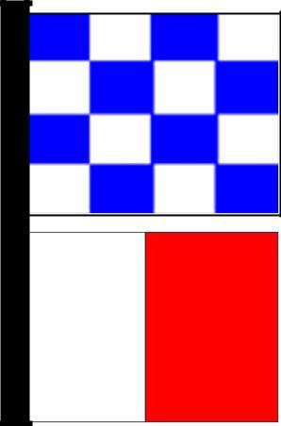
If you need to abandon a race and send the fleet ashore then you should raise flag N over flag H accompanied by THREE sound signals. It would be advisable when on the tide to also broadcast this on channel 37(M) so all the safety boat crews are aware of your intentions.

Finishing the Race
As the boats cross the line give the first 3 in each class a quick sound signal. Record the sail number and the elapsed time of finishing (handicap races).

When all boats have finished take the shortened course flag down (if being used) and start the next race or start to pack up.

Please ensure that all kit is put away and halyards are firmly secured. Lock the cabinet. If anything was missing or has been damaged please contact the Official Starter as a matter of urgency.

Recording the Results

Write up the results as neatly as you can and, and as soon possible take a picture of the draft results and send it to results@wksc.org.uk. This should be done after the first race, and again when the second race is completed etc.. Upon returning ashore, you should write the results neatly and again take a picture of the hard copy and send it to results@wksc.org.uk. The hard copy should be placed in the correct slot in Club foyer. You should also put a copy in the box in the race officers cupboard, This is just in case one goes missing.

It is important to make sure that what you write is correct. If a result is recorded wrong it is up the competitor and the race officer to inform the sailing secretary of the correct result as soon as possible after the results have been posted.

If there are any protests and you are given the Protest Form, sign it with date and time - and pass to Sailing Secretary/assistant sailing secretary or any Flag Officer.

Finally

Your final duty of the day is to lower the club burgee and ensign off the main mast. (This remains up if the ensign is at half-mast).

Dutyman

You will be emailed 7 days and 3 days before your race officer duty to remind you. If you haven’t let us know your current email address you need to do this as soon as possible.

The dutyman system allows you to swap your duties with other people. All the information is available on the dutyman website.

Notes:

