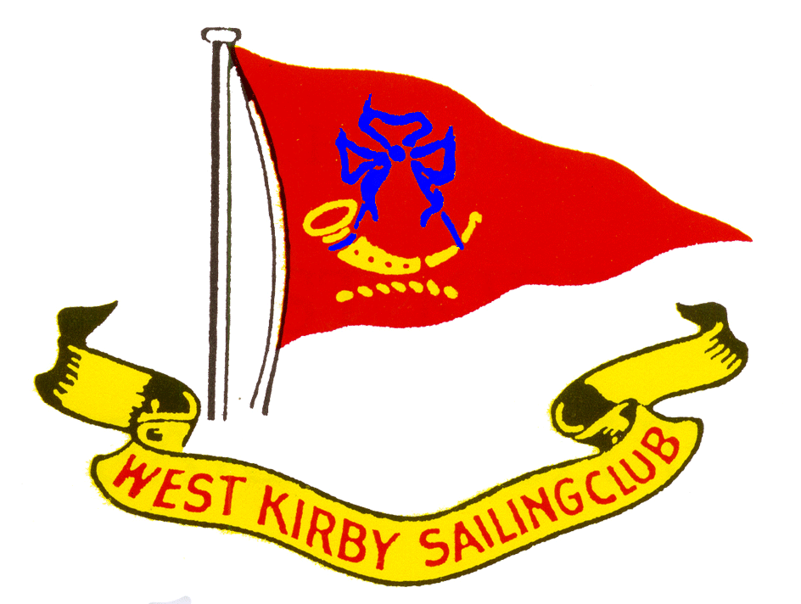
NOTICE OF RACE
SOLO CLASS OPEN MEETING
WEST KIRBY SAILING CLUB

Saturday 22nd April 2023
High tide 13.08 hrs / 9.13 m
Warning signal first race not before 11.30 Hrs
Three races back to back on the Dee estuary.
Organising Authority. The organising authority is West Kirby Sailing Club
Rules. The Open Meeting will be governed by Racing Rules of Sailing (RRS), RYA
prescriptions and the Sailing Instructions which take precedence in the event of any difference with the Notice of Race or other relevant documents changing Rule 63.7.

The Advisory Hearing and RYA Arbitration of the RYA Rules Disputes Procedures may be available.

Adequate personal flotation must be worn whilst afloat

Advertising. Advertising will be restricted in accordance with Class Association rules.
Eligibility and Entry.
- Eligible boats and competitors may enter by completing registration at the Clubhouse from 09.00 on 22nd April until the first race.
- Eligible boats must have:
i a current measurement certificate available for inspection.
ii a minimum of £3,000,000 third party insurance.
iii Correctly numbered sails unless prior written permission is given by the Race
Committee, varying Rule 77.

Fees. The entry fee is £10 per boat.
Entry. WKSC will be open for entry and registration from 09.00 hrs on the day.

Briefing. There will be a briefing at approx. 10.45 hrs and the warning signal for the first race is expected to be at 11.30 hrs.
Sailing Instructions. The Sailing Instructions will be available at registration.
Venue. Directions to the Club are available on the Club website www.wksc.org.uk.

Racing area
Racing will be on the River Dee. Should conditions require it racing may be transferred to the Marine Lake. Separate sailing instructions will be used, and there will be a separate briefing before any lake racing.

The Courses. The courses will be shown in the Sailing Instructions. In general terms the courses will be sausage / triangle or windward / leeward formats according to conditions at the time.
Scoring. The Low Point Scoring System of Appendix A will apply. One race is required to be completed to constitute a series. If 3 races are sailed there shall be 1 discard.

Disclaimer of Liability. Competitors participate at their own risk. See RRS rules 3 and 4, Decision to Race and Acceptance of the Rules. WKSC will not accept any liability for material damage or personal injury or death sustained in conjunction with or before, during, or after the event

Risk Statement
- RRS Rule 3 of the Racing Rules of Sailing states: “The responsibility for a boat’s decision to participate in a race or to continue racing is hers alone.”
- Sailing is by its nature an unpredictable sport and therefore inherently involves an element of risk. By taking part in the event, each competitor agrees and acknowledges that:
  - They are aware of the inherent element of risk involved in the sport and accept responsibility for the exposure of themselves, their crew and their boat to such inherent risk whilst taking part in the event.
  - They are responsible for the safety of themselves, their crew, their boat and their other property whether afloat or ashore.
  - They accept responsibility for any injury, damage or loss to the extent caused by their own actions or omission.
  - Their boat is in good order, equipped to sail in the event and they are fit to participate.
  - The provision of a race management team, patrol boats and other officials and volunteers by the event organiser does not relieve them of their own responsibilities.
  - The provision of patrol boat cover is limited to such assistance, particularly in extreme weather conditions, as can practically be provided in the circumstances.
  - Their boat is adequately insured, with cover of at least £3,000,000 against third party claims.
- Each competitor and boat owner shall ensure that their support persons comply with the rules.

Rights to Use Names and Likenesses. Competitors automatically grant to the organising authority without payment the right in perpetuity to make, use and show any visual records of, or relating to the event. They also allow their names, age category, club and boat details to be displayed in competitors’ lists and in results, both on relevant websites and in publications.
For more information, please contact John Dixon (Tel 07764 559 957 / email dixonjohn1948@gmail.com )
V2 08/03/23

